USER1 with **RW** access for Branch BZ only

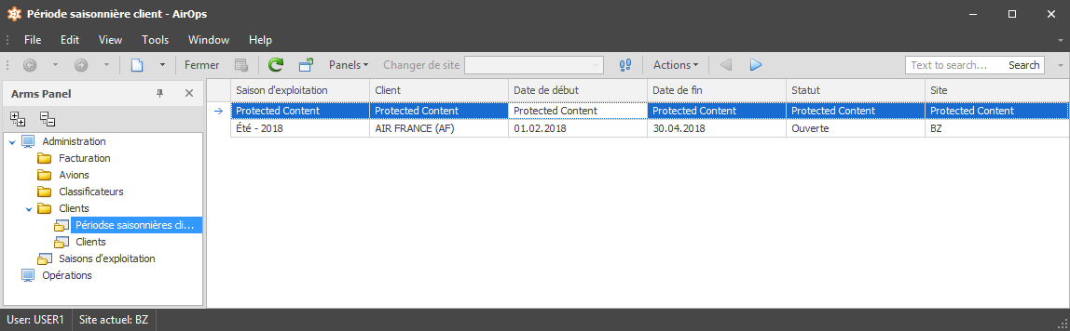

USER2 with **Read** access for Branch PN only

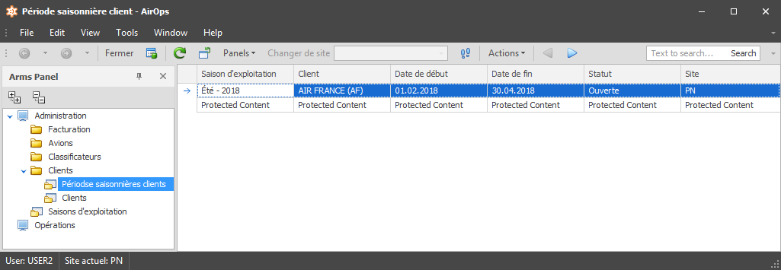

Admin

